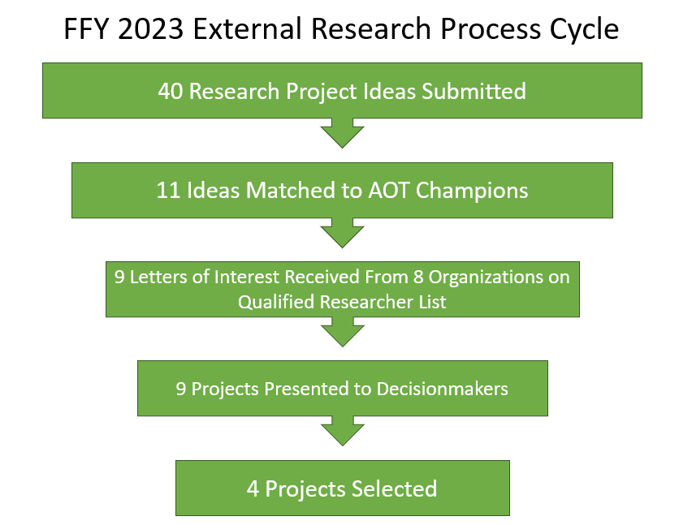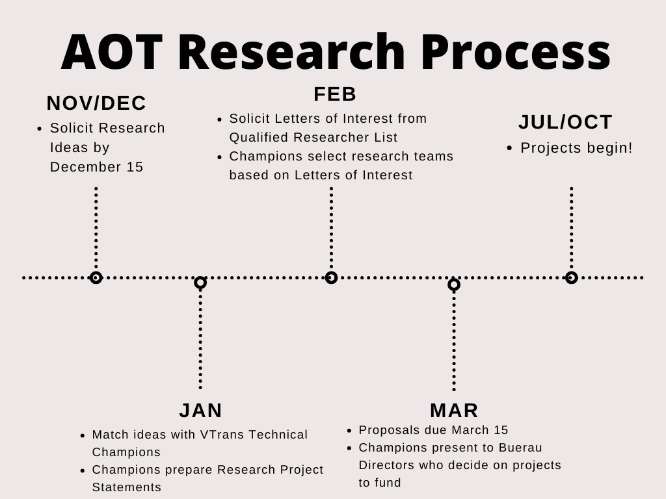

**Do You Have a Research Idea?**

**Will you Champion Your Idea that Fits an AOT Need?**

**Submit Your Idea!**

* Google “VTrans Research Idea Submission”
* Go to… <https://vtrans.vermont.gov/planning/research/resources>