Engaging with AOT Research

**Project Champion**

AOT Research uses Project Champions from across the Agency. Research Ideas are matched with an enthusiastic technical Champion. The Champion then develops a Research Problem Statement that is distributed to the Qualified Researcher List, selects the research team based on 2-page Letters of Interest, works with this research team to get a 10-page project proposal they want to advocate for, and then presents project description and benefits in four minutes in front of Bureau Directors and Deputy Division Directors all before the project is selected for funding. After the project is selected, the Champion identifies Technical Advisory Committee members, reviews project deliverables, and implements the project.

**Technical Advisory Committee (TAC) Guidance**

****All VTrans led projects have Technical Advisory Committees. The Technical Advisory Committee (TAC) is made up of

* Technical Champion
* Research Staff
* AOT Staff from different Bureaus and Divisions
* Technical Staff from other Agencies
* Regional Planning Commission staff

**The more participation of the TAC members, the more project guidance, and the more implementation potential for the project.**

**National Cooperative Highway Research Program (NCHRP)**

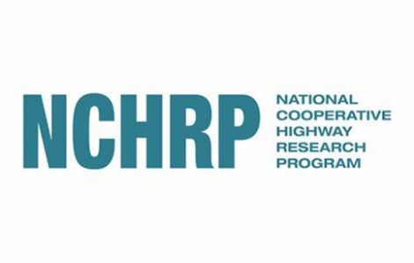All states vote on 120-150 potential projects a year in Feb/March

AOT has a SharePoint site to provide 0 to 5 votes and technical comments on all potential projects

If you rate a project a 4 or 5 (beneficial to VT) we hope that you will consider sitting on the project panel

Project panel – great way to help drive the project towards helpful benefits for VT